**Build guide**

**508: Loop Detected ec500 error.core**

**Introduction:**

The ec500 is an expandable analog video synth system based on the ideas laid out by Jonas Bers in his CHA/V project. Briefly, the core concept is this: VGA monitors are still fairly ubiquitous, especially older flat-panels (although CRTs are more fun, sure). The VGA standard is readily hackable because it breaks out the six necessary components – red, green, blue, hsync, vsync, and ground – into separate pins. It’s also fairly forgiving of signals out of spec (although the ec500 tries to keep those to a minimum).

The error.core is the hub of the ec500 system – it takes 12V DC power, regulates it down to 5VDC, and provides an expansion bus that delivers power and hsync/vsync to expansion modules. It also has the connector where various interfaces – currently just VGA, others TBD – attach.

It has 9 oscillators, all of them square-wave. 6 are simple, not voltage-controllable, and provided by a single 40106 IC. 2 of them are provided by a 556 timer IC, and are voltage controllable with variable pulse-width. 1 is provided by the VCO in a 4046 PLL chip, which also provides a phase-comparison circuit. All of the oscillators are syncable, and 8 have switchable capacitors for speed control.

Beyond that, there are three mix busses (R, G, B), as well as switches to control whether RGB signals are passed thru from whatever external source is connected.

You can read more about the details of this setup in the owner’s manual.

**A caution to builders:**

Well over half the components here are surface-mount. Most of them are pretty widely spaced, but a few are necessarily bunched up. There are quite a few surface-mount ICs in addition to the passives (which are all 0805 size). As DIY projects go, this is an intermediate project and you should probably have a few previous builds under your belt, including some previous SMT work.

These build notes don’t cover everything; for the most part, you’ll just be following the BOM and there’s not a lot of commentary necessary.

**The build:**

I start on the back, with the SMT passives. Sometimes I’ve done the SMT ICs first, and honestly, it’s about as straightforward either way you go. If you don’t have a ton of SMT experience, go watch the EEVBlog tutorial video on YouTube. Then you might want to start with the caps, since they’re slightly bigger & don’t have a top or bottom.

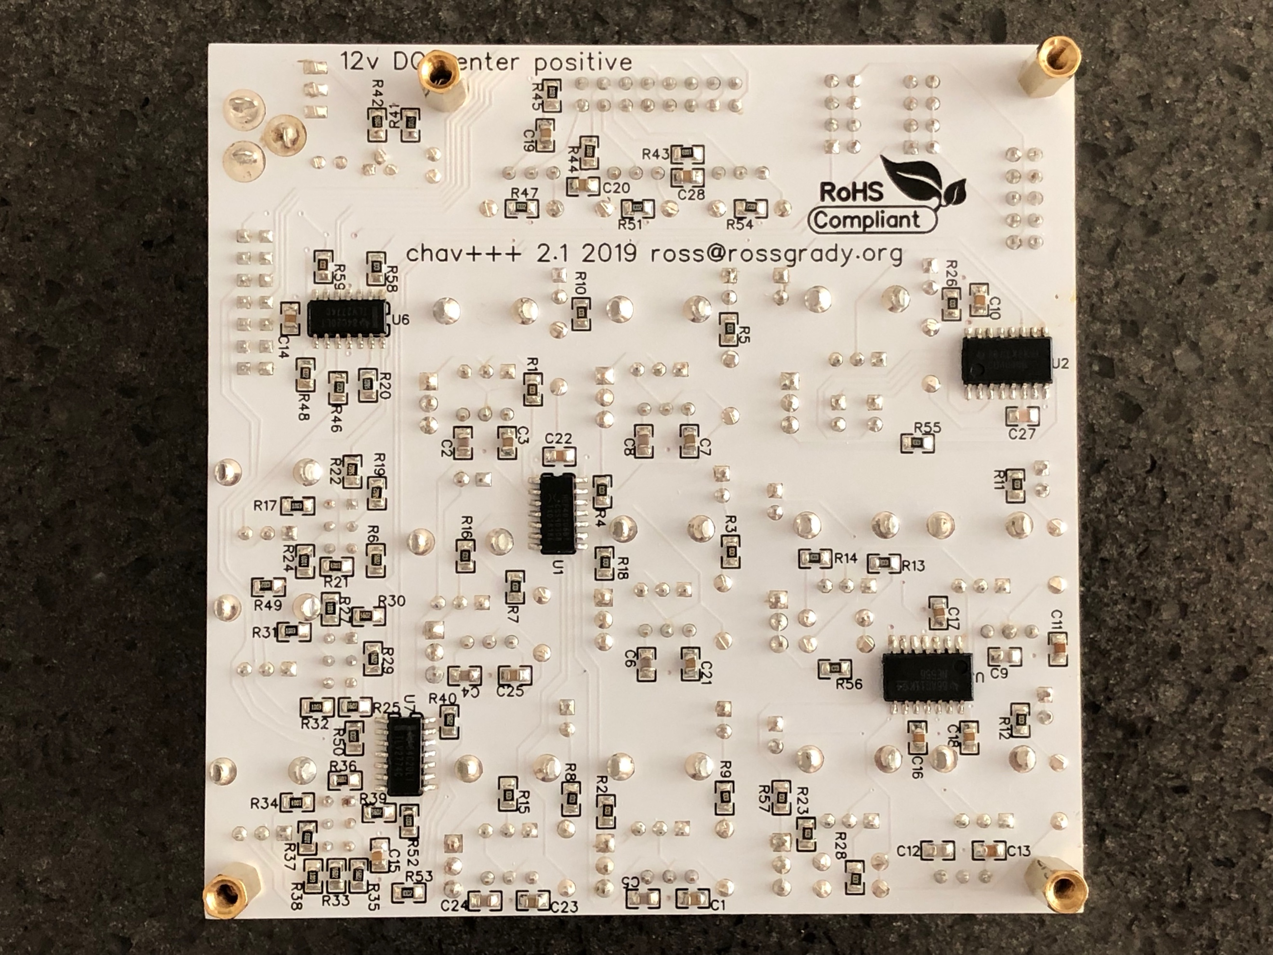

Pin 1 on the IC footprints is marked with the traditional notch out of one end.

Beyond that, I’m not going to take you through value by value. Use the BOM and take your time.

On the front side, you’ve got the following:

* Diodes (4148s and 5817s)
* One LED
* One transistor
* One electrolytic capacitor
* One 7805 voltage regulator
* 11 switches
* 14 potentiometers
* A jillion little 1x2 and 1x3 female headers
* A smaller number of M + F multi-pin headers
* Some brass hardware

Start with the diodes. The 5817s are D14-D16, in a single row near the top. The rest are 4148s. Match up the line on the diode with the line on the footprint.

Next, you can install the 3904 transistor, the 10uF capacitor, and the 7805 voltage regulator, all near the upper right-hand corner. You’ll want to put a bend in the 7805’s legs, just above the point where they narrow, such that it lies flat & its hole lines up with the hole in the board. These are all polarized; check the photo above for the transistor & 7805. The capacitor’s long leg goes into the hole marked +.

Next comes the fun part: installing all of the 1x2 and 1x3 female headers. The outlines on the board aren’t exactly the same size/shape as the headers, but they’re close enough that you can see whether one is crooked or not.

What I do for these headers is to hold my iron in one hand, and hold a length of solder in my other hand, while also using a couple of fingers on that hand to hold the header in place, with the PCB face-down. I then tack **one** (and only one) of the pins in place. Then you can flip it over & assess just exactly how crooked it is, and visualize how you’ll want to nudge it. Flipping back to the backside again, you can manipulate the header (while holding it in place) with one hand, and heating that one tacked pin with the iron again in your other hand. Melt, nudge, check, and repeat until it’s reasonably well lined up. It doesn’t have to be perfect – it will be covered up by the top panel – but if it’s too far off, you’ll have trouble getting the pin ends of the patch cable into the holes.

Once you have all of the 1x2 and 1x3 headers in place, do the same for the 2x3 and 2x4 headers.

Next it’s time for the switches. I’ve done it both ways, and have decided it’s actually easier to install the switches before installing the panel. YMMV. If you install them before, follow the same procedure outlined above to ensure they are straight and flush with the board. Take all of the nuts & washers off of them & put them aside, somewhere nearby but safe.

Once all the switches are in place, it’s time to put the brass standoffs on. You should have four 10mm standoffs with female threads at each end, and three 8mm standoffs with male threads at one end & female threads at the other. You should also have some tiny washers, and four M3 screws.

On top of the board, the tiny washer goes over the male end of an 8mm standoff, which in turn goes through one of the three corner holes on the board. Underneath the board, the 10mm all-female standoffs act like nuts, screwing onto the threaded ends of the 8mm standoffs sticking through from the front.

The fourth hole is the one through the 7805 – stick the M3 screw through from the front, and use the fourth 10mm standoff on the back to hold it in place. That’s it – you should have four “legs” underneath now, and three pillars sticking up on top to hold the top panel in place. Don’t put It on just yet, though.

After the standoffs, it’s time for all the pots. **There are multiple different values of pots on this board!** Don’t just put them on there willy-nilly. Put them in the right places and **don’t** solder them in place yet.

The pots we use are labeled, slightly cryptically, on the underside, like so:

1M = B105

100K = B104

10K = B103

1K = B102

You’ll also want to put the LED legs through their holes. The LED may or may not fit through the hole in the top panel, but you’ll probably want it to be up against that hole, so don’t solder the LED legs into place until after you have put the panel on & have it upside-down.

LEDs are polarized; the long leg goes through the hole closest to the top edge of the board.

Once you have all of the pots & LED in place, making sure all of their pins went through the holes & didn’t get bent over, you can put the top panel in place over the top of them.

Once the panel is fully over all of the pots/switches, and you’ve confirmed all the pots are settled into their holes on the PCB, you can use the rest of the M3 screws to screw the panel in place. If you got the female headers good & flush, then the panel should rest fairly evenly on top of the headers and on top of the three brass standoffs. You can also put the lock washer & one nut on each of the switches.

At this point, with the panel in place, I typically flip the whole assembly over & set it down on the table/workbench on the tops of the pot shafts. They should all be level with each other, and you can press gently & evenly in various spots on the back to ensure that everything is set in place. Try to make sure that none of the pots are rubbing the edges of their panel holes too egregiously.

Once you’re confident that everything is straight & level, you can just let it rest upside-down on the pot shafts while you solder everything in place. I usually do one leg on each pot first and then turn it back over once more for a sanity check before doing the rest. There are 5 legs on each pot (3 contacts & the 2 bigger bent legs that hold it in place). Make sure you solder all of them.

Once you’re done with the pots & the LED, all that is left are the three shrouded box headers, and the DC power jack. There are cutouts in the panel to accommodate them. Use a similar technique to what you used for the smaller headers – hold each thing in place with one hand while tacking one leg in place, and then check for straightness & correct as needed before doing the rest of the legs.

That should be it. Check all of your solder points, make sure you didn’t miss anything. I wash all of my boards with 99% isopropyl alcohol, a toothbrush, and some Kimwipes.

The only thing you can really test at this point is whether power is flowing, so feel free to plug in your (**CENTER POSITIVE**) 12VDC power supply and see if the LED lights up.

To do any further testing, you’ll need the ec500 VGA adapter & a short 16-pin ribbon cable, both of which you can get from 508.loopdetected.net, if you didn’t order a full kit from us. Turn your attention to the getting started section of the owner’s manual for what to do next.

-- Ross Grady, July 16, 2019